Annual Report 2023

University at Buffalo QuarkNet Center
Mentors: Profs. Ia Iashvili and Avto Kharchilava

University at Buffalo (UB, SUNY) joined QuarkNet in early 2006. Mentors of the group are UB experimental High Energy Physicists, Profs. Ia Iashvili and Avto Kharchilava. Every year, UB sponsors the Summer QuarkNet Workshop for local high school teachers and their students. This year, the Workshop took place on August 17 and 18. We had three participating teachers and one student. One of the teachers, Mr. Larry Hiller (Nichols school) has been in the program since 2006 and two others, Mr. Orlando Buria (West Seneca Christian School) and Mr. Phillip Coburn (Nichols school) have been participating for several years.

The first day of the Workshop was devoted to presentations by mentors on Standard Model of particle physics and recent results from the CMS experiment. We also gave demonstrations with the Cloud chamber and Cosmic Ray detector at UB Physics labs. Analysis of the NOvA neutrino experiment data took place on the second day of the Workshop. This was followed by discussion on the obtained results and findings. At the end of the day, teachers prepared presentations on NOvA and other neutrino experiments, and on neutrino physics. Mr. Shane Wood (QuarkNet National Staff) was facilitating the Workshop and provided valuable insights. At the end of the Workshop, we held dedicated discussions to brainstorm on how to implement these activities in the classroom curriculum.

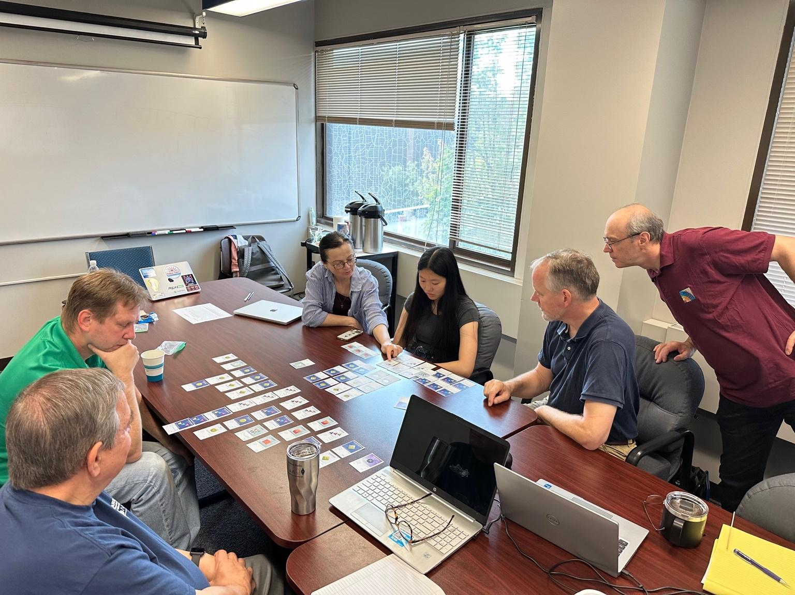
Photo: QuarkNet Summer Workshop at UB. QuarkNet teachers, a student and mentors discuss particle content of the Standard Model of particle physics.
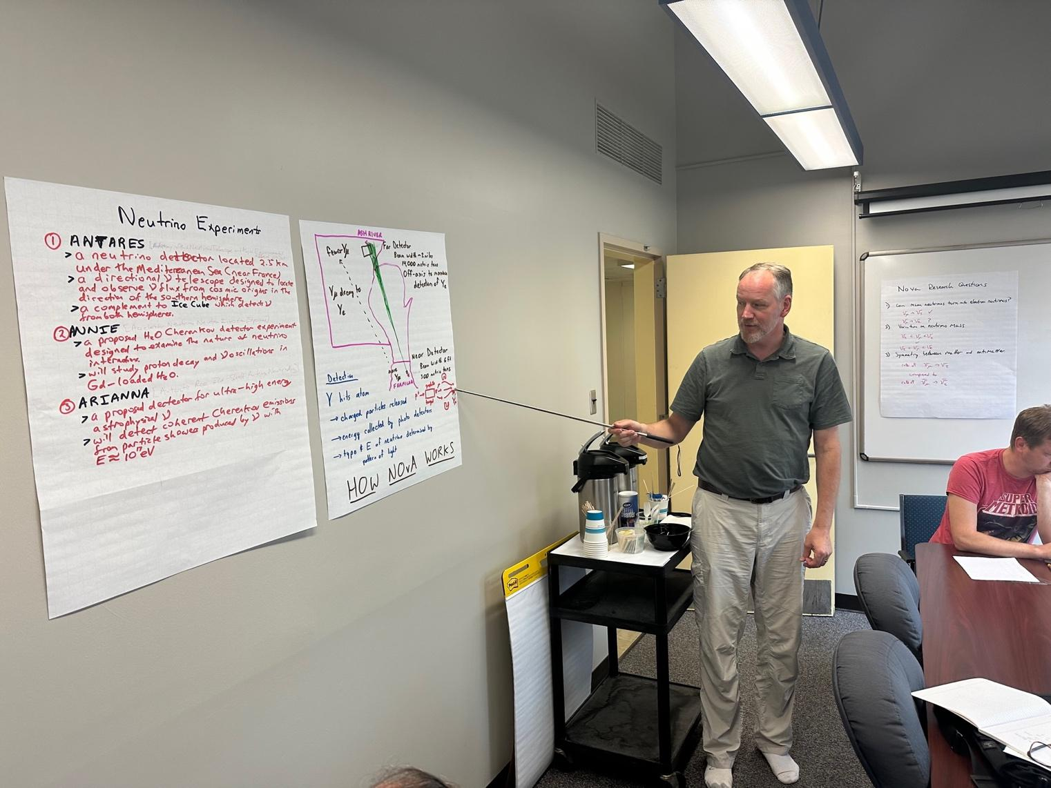
Photo: QuarkNet Summer Workshop at UB. QuarkNet teacher, Mr. Phillip Coburn, gives a presentation on the NOvA experiment and neutrino data analysis.

