The Catholic University of America QuarkNet Center – 1st Year
Annual Report
2017
Mentors: Dr. Aaron Dominguez, Dr. Rachel Bartek, Dr. Angela McRae

Two teachers participated in QuarkNet training this year. One teaches at a public high school, the other at a private school. Both teachers have extensive experience teaching physics at the high school level. The teachers attended a one week workshop at The Catholic University of America (CUA), attended the FermiLab ‘bootcamp’, spent three weeks conducting research at CERN with Dr. Bartek, and will continue to receive additional training throughout the academic year.
The training on particle physics began with an orientation program at the CUA campus. During the orientation, we crafted and aligned our goals, objectives and program expectations. The teachers attended video conferences with experts at CERN, attended lectures and read articles on particle physics. They then travelled to Fermilab for a 5-day Data Camp where they participated in site visits, attended lectures, modeled classroom activities and connected with other teachers from all over the country on team-building activities. The next stop was CERN for three weeks where they saw particle colliders in action. They learned about gathering data, maintaining machinery, brainstorming on possible improvements to data collection equipment and collaborating on problem solving. They also attended many lectures on particle physics taught by experts from many EU countries. The professional development will continue through the academic year, and will cover both particle physics research and pedagogy. The teachers will also build a cosmic muon ray detector model where the goal is to bring a hands-on particle-physics experience to the classroom.
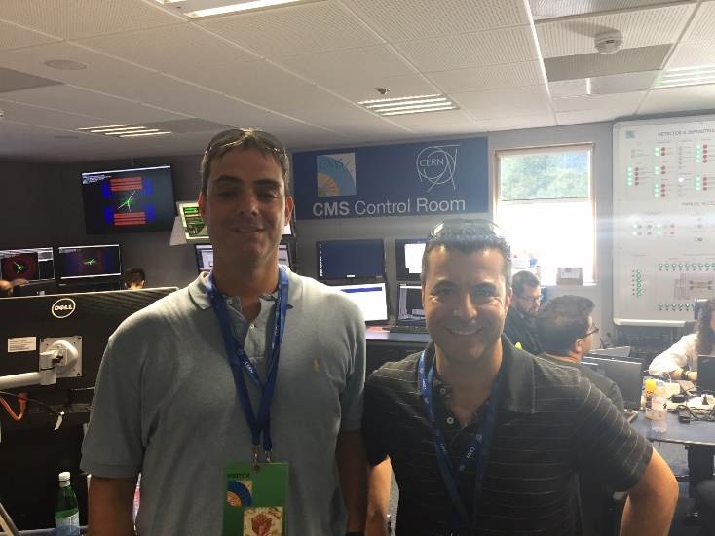
QuarkNet teachers in the CMS Control Room at CERN

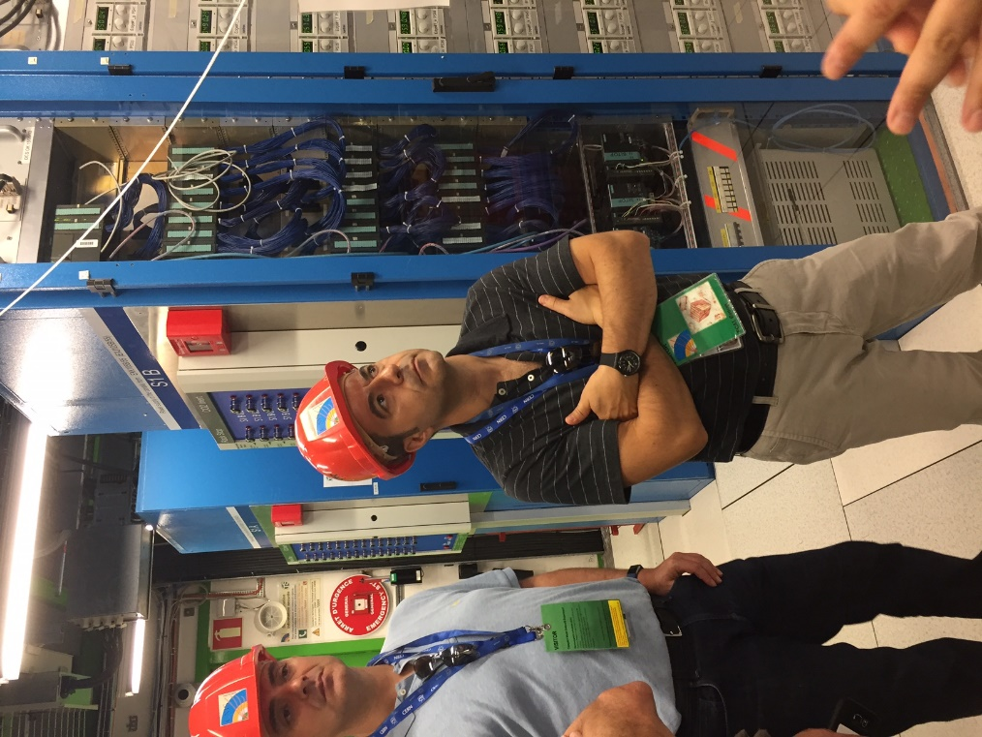
Teachers on tour at Point 5

