Quarknet: CERN Open Data Analysis

Participants:

Jane Nachtman, Mike Grannen, Andrew Haffarnan, Josh Turner.

Purpose:

The higgs-boson was a key piece of evidence in assisting to prove the standard model. However, many physicists believe that the standard model is a small, low-energy section of a greater theory. In order to prove this hypothesis, one would need to find new particles that could outline a new model.
The Compact Muon Solenoid (CMS) at the Large Hadron Collider (LHC) allows public access to data taken before a certain date. We, using said data, are attempting to find a theorized particle. This particle, Z prime (Z’), is theorized to decay into both a higgs-boson and a photon. If this particle is found, it could assist in outlining the new model that many physicists are hoping to find.

Method:

In order to find the theorized Z’ we first outlined its decay. According to model that defined it, it would first decay into a Higgs-boson (H⁰) and a photon (ɣ). We then decided how we would find the H⁰. The two options that seemed the most reasonable were H⁰ to Z pair wherein the Z pair decay to 4 leptons of di-muon pairs,
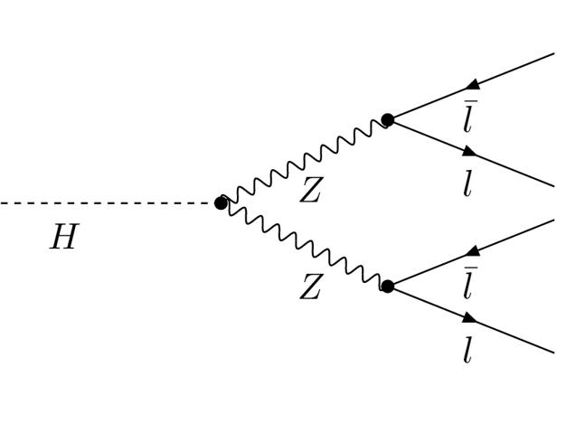
and H⁰ to bottom-anti-bottom pair.
h
b
_
b
We decided to use H⁰ to Z pair to di-muon pairs, because it would be the easiest analysis to code. As a preliminary test, we decided to run a program to find the Higgs-boson, as it is a part of Z’, and so we need to find the Higgs-boson first. To do this, we coded a program that would find two distinct di-muon pairs.
It was run with approximately 39,500,000 events, and it found 9 candidates. The overall time taken was approximately 36 hours. The graph is shown below.
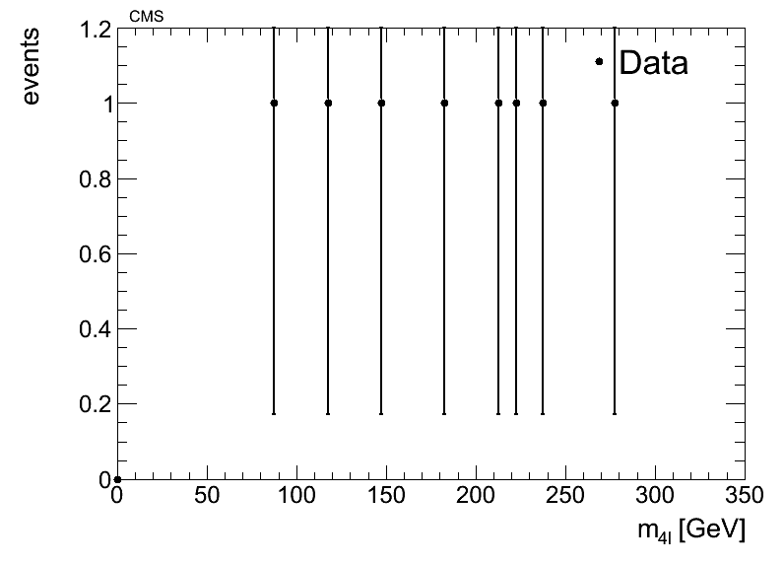

Conclusion:
In order to search for Z’ we would need to further narrow those events by filtering out those that do not have a photon present, because Z’ decays into both the Higgs-boson and a photon. However the Higgs-boson alone has already taken 36 hours to find 9 candidates. To do a proper analysis, we would need at least several hundred candidates.Therefore, with our current equipment and timeframe, we found that it is not feasible to search for Z’. If one had access to a computer with a significantly faster processor or were able to export the program onto a network of computers, it would not be difficult to analyse enough events to find a proper amount of data.

