Summer 2022 Quarknet Workshop at Syracuse University
The Syracuse group hosted a Quarknet workshop from Aug 8-10, 2022. The program was developed by Profs. Steven Blusk, Shane Wood (Quarknet Staff), and our lead teachers Michael Madden and Brian Bealer. Seven teachers were able to join the workshop. A photo of the participants is shown below.

Photo showing the Quarknet 2022 participants: (From left to right): Alexa Estock, Brian Bealer, Craig Dowler, Matt Rudolph (fac), Beth Carpenter, Dan Kurzen, Chad Gregory, Josh Buchman, Steve Blusk (fac), Shane Wood (Quarknet).

Among the group, we had two new participants to Quarknet, Dan Kurzen and Beth Carpenter.
The three-day workshop program is available at the following page
https://quarknet.org/content/2022-syracuse-university-workshop
Monday’s program featured a mix of talks and activities introducing basic particle physics concepts. We started off the program with the classic ‘Rolling with Rutherford’ data activity, except with a twist. Two different size targets were used, and several sizes of balls were rolled at the target. By using different size projectiles, teachers recorded the number of “hits” for each projectile size, and then extrapolated to zero size to determine the size of the target. A good discussion of uncertainties arose, in response to the variations of the data about a straight line fit. A photo of one group’s experimentation is shown below.
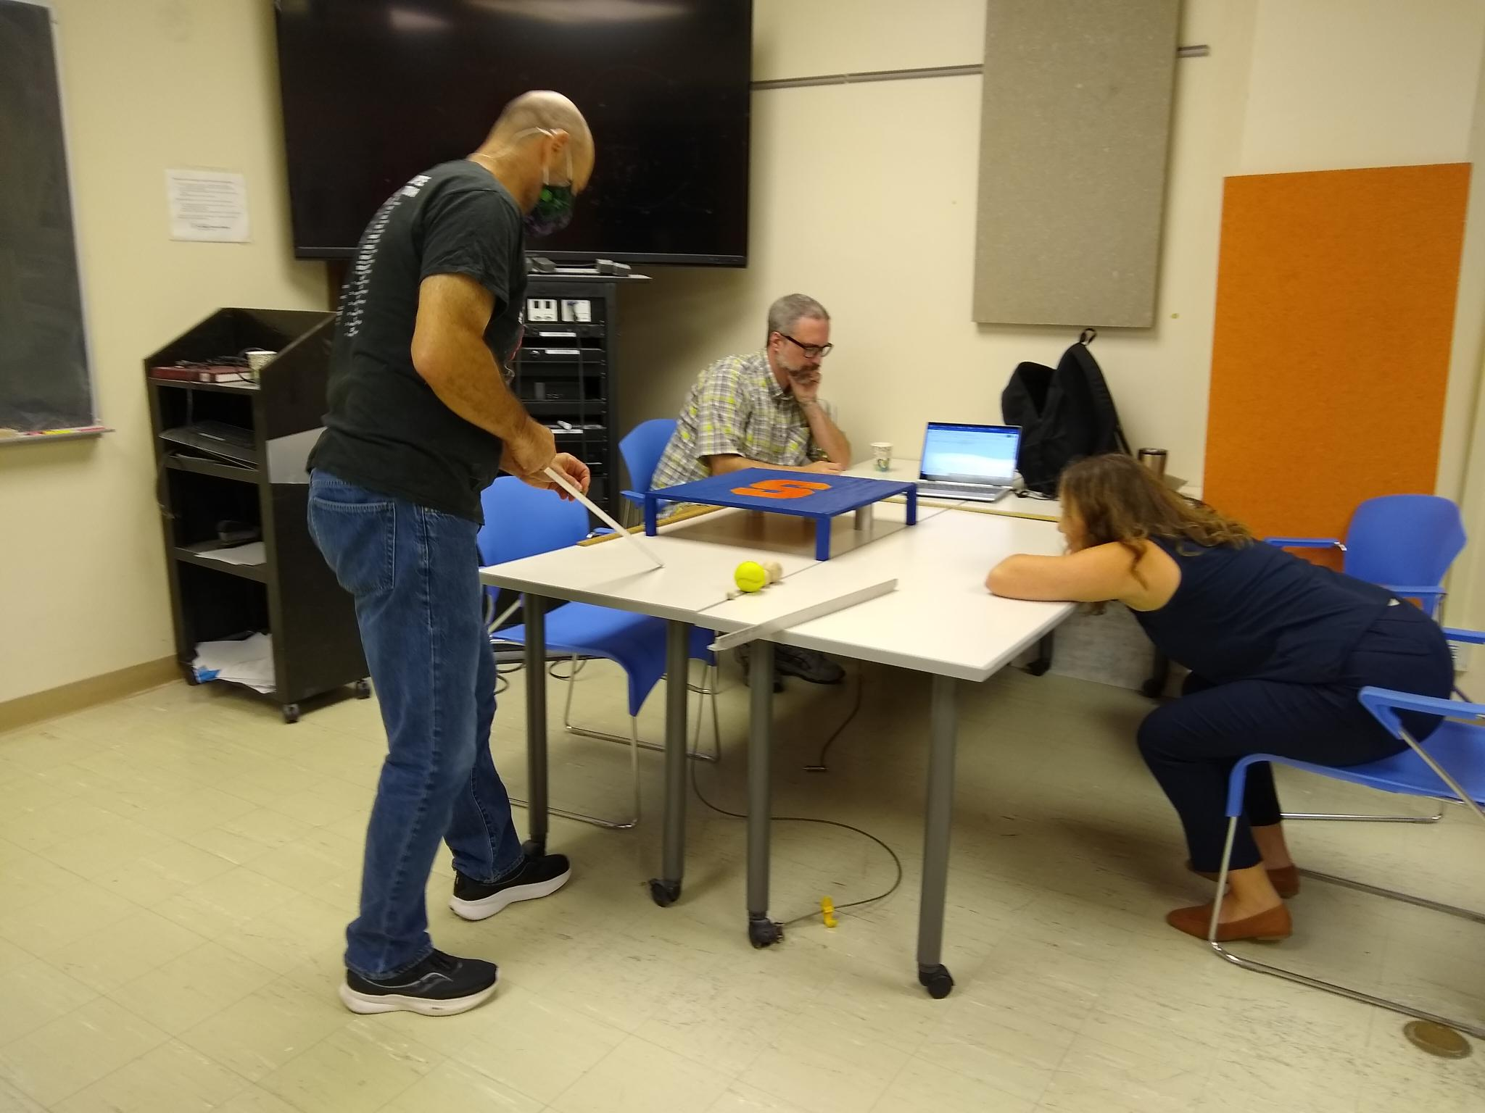

After a short break, the activity was followed up with a talk by Prof. Rudolph on ‘Cross-Sections’ in particle physics, and how the Rutherford activity parallels cross-section measurements of various processes at CERN. In the afternoon, we reminded teachers of the full suite of activities in the data analysis portfolio section of Quarknet. We then worked through the ‘Mass of US Pennies’ activity and ended the day with a tour of the high energy physics laboratory, where they got to see silicon detectors under a microscope, and the Upstream Tracker staves up close.
Tuesday was, in large part, dedicated to the Higgs @ 10 suite of activities. Teachers were organize into 3 groups and worked through the ‘Shuffling the Particle Deck’ to think about the multiple ways to organize the standard model particles. After a break, teachers worked researched background information on the Higgs boson in the “Where is Higgs?” activity, using provided resources, to try and answer the questions, (1) What are the Higgs field and the Higgs boson, (2) What are some pre-LHCb efforts to discover the Higgs boson, and (3) How was the Higgs finally discovered. Teachers fro each group presented their findings to the rest of us.
Teachers Dan Kurzen and Beth Carpenter presenting their findings on ‘Where is Higgs’ to the rest of the group.
After a discussion on their findings, Prof. Blusk gave a presentation on the Higgs boson – what is it and what have we learned about it. In the afternoon, we worked through the Z mass data portfolio activity where they learned about how we compute an invariant mass. This was followed by an introduction to the iSpy activity, where the teachers sifted through four-muon candidate events to reconstruct Higgs boson candidates.
Wednesday began with a couple of presentations by graduate students at Syracuse on the physics of LIGO and some of the technology used in the LIGO interferometer. This was followed by tours of two of the LIGO laboratories at Syracuse. After a short break, we watched a short video from Don Lincoln about how particle accelerators work. Afterward, Shane Wood introduced us to the “Making it Around the Bend” DAP, and showed us the usage of the mass spectrometer animation to learn how students can experiment with the effects of electric and magnetic forces on charged particles. This was followed by the activity on “Mapping the Poles”, led by Brian Bealer, one of our lead teachers. In the tradition of the previous two days, we also had a presentation by Prof. Rafael Silva-Coutinho on the recent results from flavor physics experiments that begin to question Lepton Flavor Universality. After a pizza lunch, we engaged in a Share-a-thon, where teachers shared some resources that they have found to be particularly helpful in their teaching. It was very exciting to see all of the great resources that are being used to enhance student’s learning. Prof. Blusk then led a discussion on ‘how do we teach the laws of physics?’ The idea was to flesh out the message we send to students that the physical laws are always being tested in experiments. Moreover, that physical laws generally have some limits of validity. For example, Newton’s Law of Gravitation cannot be applied to understand what happens near a black hole, or classical laws cannot describe accurately, or at all, subatomic phenomena.
The workshop concluded with some time to think about implementation of some of the ideas that were presented at the workshop, and a workshop survey.

