Attenuating Circumstances
Teacher Notes

Description
Particles passing through a medium interact with matter, lose energy, and are absorbed or decay. This process is attenuation, one definition of which follows the Beer-Lambert Law N = N₀e^{-x/λ} where N is the number of particles remaining from an initial sample of N₀ particles after penetrating a distance x into a medium; λ is then the attenuation length of a beam of a particular kind of particle penetrating a particular medium with a given energy, defined as the distance at which N= N₀/e.

The attenuation lengths of subatomic particles can be measured with special equipment and training. To show how particles attenuate in the classroom, we use a simple analogy with marbles rolling (and stopping) on a carpet. Students roll a sample of marbles (N₀ = 20-30) from a cup onto a carpet in a particular direction with a particular energy, determined by the initial height of the cup. They then count the number of marbles in ~30 cm bands from the starting point so that they can calculate the number marbles in that bad or farther. The students make a histogram of N as a function of x and analyze it to find the attenuation length of the marbles on the carpet. The experiment may be repeated to replicate results or to make a master plot with all marbles.

Standards Addressed
Next Generation Science Standards
Science and Engineering Practices
4. blah
Crosscutting Concepts
1. blah
Common Core Literacy Standards
Reading
9-12.7 yadda
Common Core Mathematics Standards
MP5. Yadda

International Baccalaureate
SL Core and Extension
HL Core and Extension

Advanced Placement
Physics 1
Physics 2
Physics C Mechanics
Physics C E&M

Enduring Understanding
The extinction of particles in a beam through matter depends on the physics of the interaction and uncertainties which give rise to a probabilistic distribution.

Learning Objectives
Students will know and be able to:
- Interpret a histogram with exponential decay.
- Given appropriate data, characterize the attenuation of particles by the attenuation length.
- Explain attenuation of particles using a simple model.

Prior Knowledge
Students must have some familiarity with plotting histograms; students should be able to explain why a rolling marble comes to a stop based on energy considerations.

Background Material
Students can learn more about attenuation of particles at:
- Attenuation length article in Wikipedia, https://en.wikipedia.org/wiki/Attenuation_length
- Article in A Quantum Diaries Survivor (somewhat different definition), https://dorigo.wordpress.com/2008/04/11/calorimeters-for-high-energy-physics-part-2/
- National Physics Laboratory Kaye and Laby Table of Physical and Chemical Constants, http://www.kayelaby.npl.co.uk/atomic_and_nuclear_physics/4_5/4_5_2.html

Implementation
In each of several trials, students fill a cup with 20-30 marbles. They spill the marbles on a carpeted floor in one direction, as shown in Figure 1. Once the marbles have been scattered, students count them in fixed bands, say 30 cm.
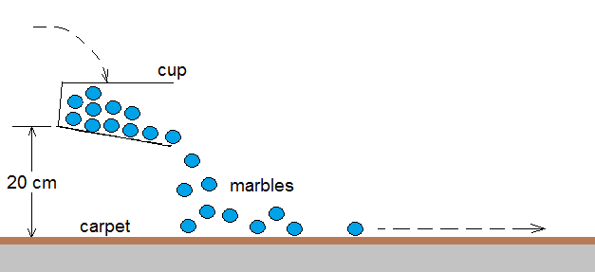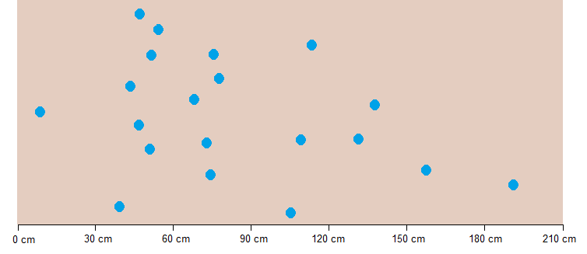
Figure 1. Spill the marbles. Figure 2. Count the spread-out marbles in 30 cm zones.

Using the fictional, arbitrary example in Figure 2, students would record the number of marbles left in each band. They would then subtract the number in the each band from the previous total. Thus, in Figure 2, we can presume there were initially 20 marbles. Students subtract 1 at the end of the first band, so there are 20-1=19 marbles left. After the second band, they subtract the 7 marbles left there, so we get 19-7=12 marbles, etc.

The students then make a table and a plot as in Figure 3.
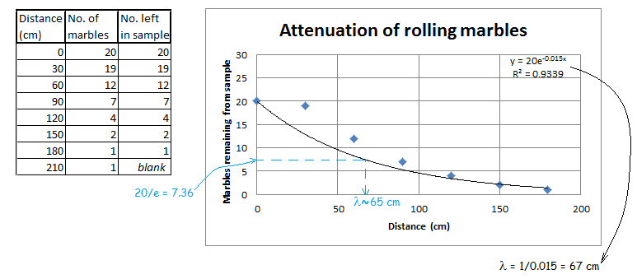
Figure 3. Create a data table and plot.

In the table, the “blank” is for the final result of 0 marbles left; this is rendered as blank so it will not go in the plot, which will be fitted to a negative exponential; a zero will not calculate. The plot shows two ways to get the attenuation length. The first is, using a spreadsheet or graphical analysis program, to introduce an exponential fit. Note that the value at distance 0 cm is fixed in this example since students would know they started with 20 marbles: this is a choice, not a directive. The fit gave us a function of y = 20e^{-0.015x}. As shown in the figure, 0.015 is 1/λ so λ=67 cm according to this method.

On the other hand, the plot can be drawn on graph paper and the curve fit made by eye-and-pencil. Assuming students would get about the same curve this way (by no means assured) we have the sample plot-by-hand calculation in blue: the attenuation length is the value of the distance when, according to the plot, the number of remaining marbles is the initial number divided by e. Here, the approximate result is λ=65 cm.

Students can do multiple trials (keeping the number of marbles, the height of the cup, etc. constant) and either compare values of the attenuation length from trial-to-trial or combining all trials to make a master plot.

Assessment
Students may be assessed on the plots and their calculations of attenuation length; these are important but not enough. Students should be able to apply their understanding of the attenuation experiment using marbles to explaining how ionizing particles penetrate a material. A good way to do this is to design a cosmic ray experiment to find the attenuation length of cosmic ray muons as they penetrate through an absorber and explain both expected results and the limitations of the experiment.

