BENCHMARK IMPLEMENTATION DOCUMENTATION
1 | Benchmark Maintenance (Benchmark Menu Item) | Page Content and Workflow
 | 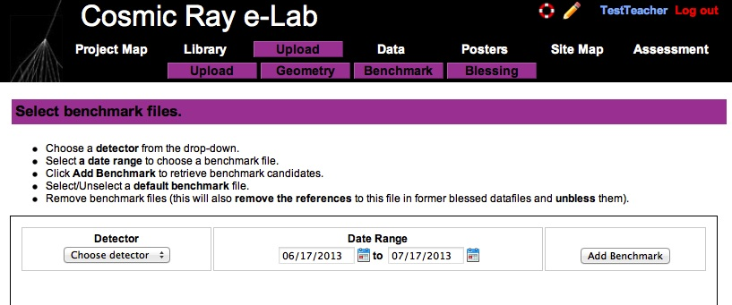 | A – Choose a detector from the dropdown.  B – Select a date range to retrieve benchmark candidates.  C – Click Add Benchmark

2 | Add Benchmark File (Popup) | Popup Content and Workflow
 | 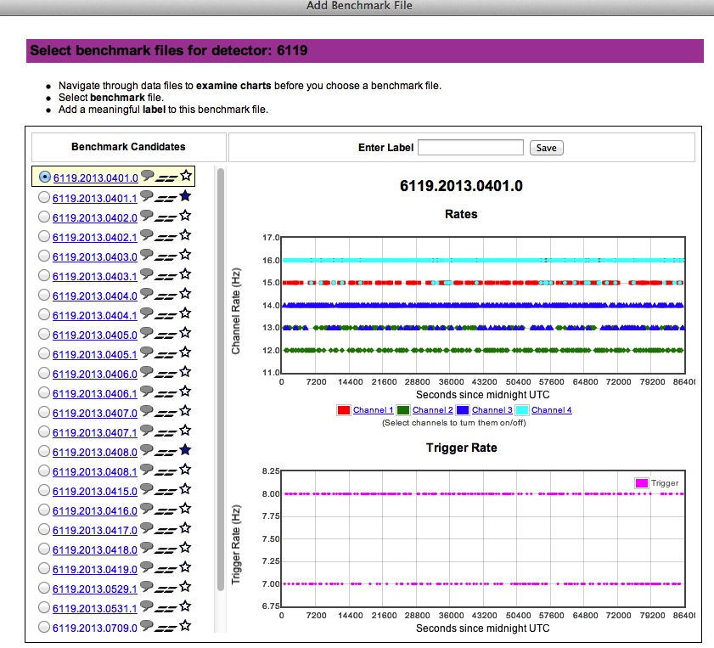 | A – Candidate files for selected detector. These files have a *.bless file associated with the datafile.  - Popup opens and displays the charts for the first datafile in the list.  - Select each file to view the charts. Now user can navigate with up/down arrows.  - User can add comments by clicking on the balloon. Also added icons for stacked/unstacked and blessed/unblessed (these last two are not clickable, just indicators).  - Enter a label at the top of the popup and save it.  - will display messages if any problems (ie: a label for this file has not been entered).  - Popup returns with message that the file has been added a link to close the popup.  Note: if the detector doesn’t have *.bless files associated with its datafiles for the chosen date range, it will display a message when the popup opens.  Metadata:  - Former benchmark:  - benchmarkdefault (false)  - Save new benchmark:  - benchmarkdefault (true)  - blessed (true)  - benchmarklabel (String)  - benchmarkfile(true)  - benchmarkreference(none)  - duration (int)  - chan1Rate (float)  - chan2Rate (float)  - chan3Rate(float)  - chan4Rate(float)  - triggerRate(float)

3 | Benchmark Maintenance (Benchmark Menu Item – Back from Add Benchmark popup) | Page Content and Workflow
 | 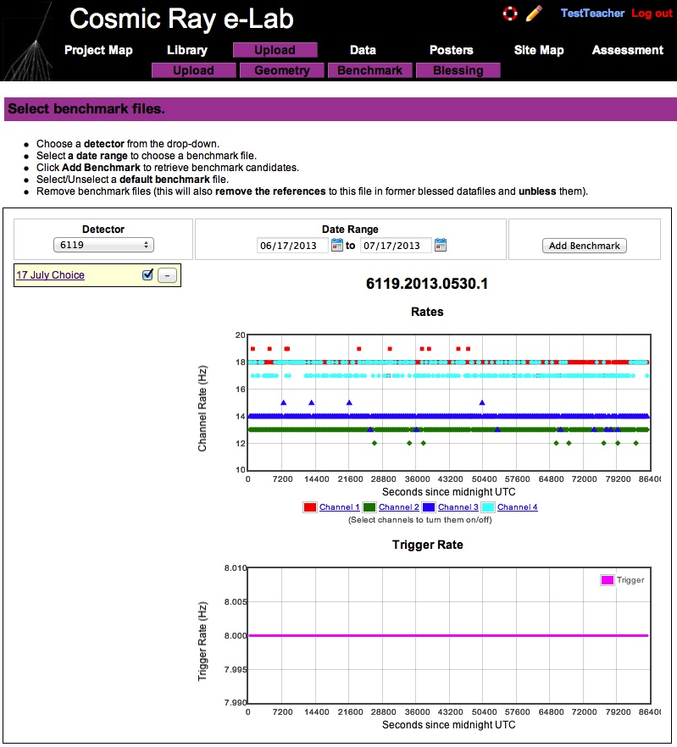 | A – List of all benchmark files by detector.  - Default flag: works as a radio button. Only one file can be the default.  - Remove benchmark files. Note: It won’t allow the user to remove a default file. If the benchmark is removed, the code clears the benchmark reference in all the datafiles that have been blessed using this benchmark file and unblesses the files.  - Meaningful label that needs to be entered when adding benchmark files.  B – By selecting each benchmark file, the bless charts are displayed on the right. User can navigate up and down the list of benchmark files with arrow keys.  Metadata:  - Default flag:  - benchmarkdefault (true/false)  - Remove benchmark:  - benchmarkdefault(false)  - benchmarkfile (false)  - blessed (false) in all blessed files using this benchmark.  - benchmarkreference (“”) in all blessed files using this benchmark.

3 | Upload Data with Benchmark (Upload Menu Item) | Page Content and Workflow
 | 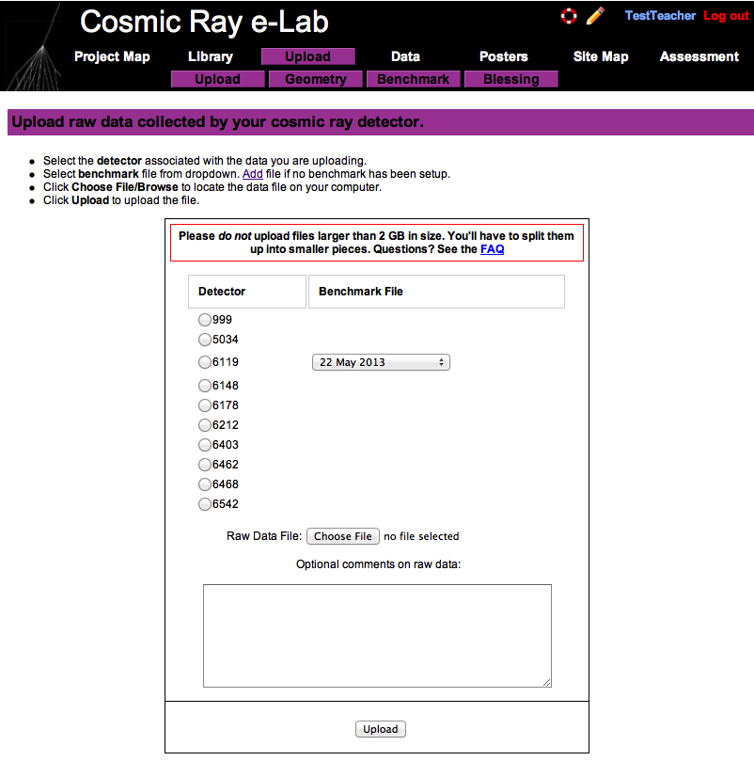 | A – List of Detectors (as before)  B – Dropdown with benchmark files per detector. The default benchmark is selected but other benchmark files can be selected for any upload (No Benchmark option added to the dropdown). Note: if no benchmark file has been set up, I added a link to the instructions above or users can go to the benchmark link on top.  C – Choose File (as before).  D – Upload (as before).  Note: this page only passes the benchmark info to the upload-results.jsp page. Once the code returns from Split.pl a function is called with the split datafiles and the benchmark and the code will analyze whether these just uploaded files are blessed/unblessed. (see Upload Results).

4 | Upload Results (Results page that comes after the upload process finishes) | Page Content and Workflow
 | 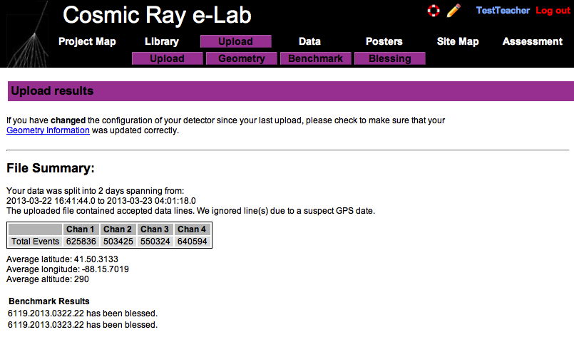 | A message to the user is displayed at the bottom.  Note: for the time being I am creating a text file in the server (for each data file) with the output of the routine that decides whether the file is blessed or not as well as any output error. The intention is to get rid of the creation of this output file as soon as we are done with the testing and we are confident that the routine is working OK.  Metadata:  - Datafiles just uploaded:  - blessed (true/false)  - benchmarkreference(String)  - blessedstatus(String)  - benchmarkfail(String)

5 | Blessing Process (Blessing menu item) | Page Content and Workflow
 | 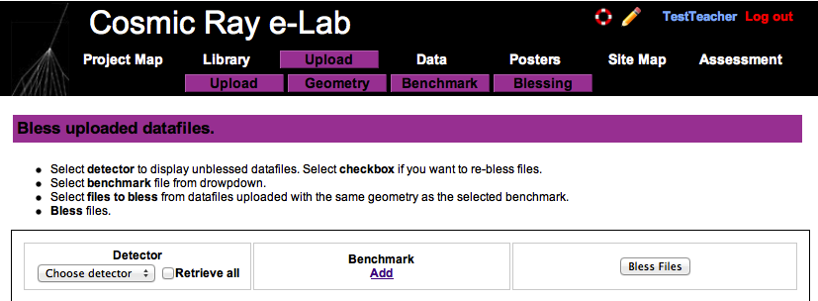 | A – Choose Detector  - If the detector has a default benchmark file, it will retrieve all the datafiles that have not been blessed yet and were uploaded with the same geometry as the benchmark file. The default benchmark file can be changed.  - Select “Retrieve all” to bring all files associated with this detector and the geometry of the default benchmark. User can re-bless files.
 | 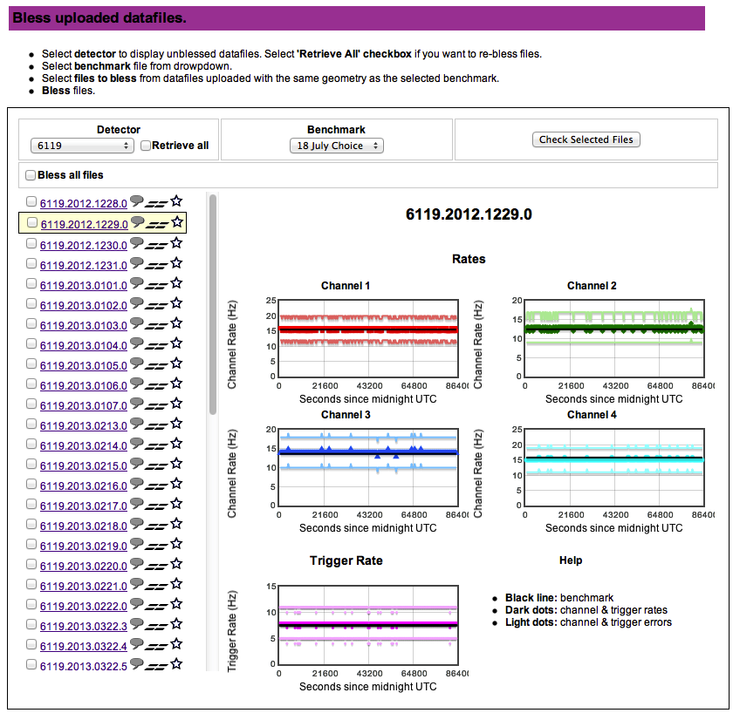 | B – User will see all the files that were uploaded with the same geometry as the benchmark.  - the benchmark file can be changed and the list will be refreshed.  - Select which files need to go through the blessing routine and ‘Bless Files’.  - The results (blessed/unblessed) will show at the bottom of the page after the process completed.  Metadata:  - Datafiles selected:  - blessed (true/false)  - benchmarkreference(String)  - blessedstatus(String)  - benchmarkfail(String)

