Cosmic Ray Classroom Activity; “Know Your Machine”
Now with Student Prompt (SP) and Teacher Commentary (TC)

Example Activity Template:
http://ed.fnal.gov/data/phy_sci/rolling/activity.pdf

Description
The purpose of this study is to introduce how errors are detected and interpreted in the performance of the Cosmic Ray Muon Detector (CRMD). Initial data was collected under nearly optimal conditions. A performance study was conducted on this initial data. The voltage of one of the counters (Counter Two) was then changed from 0.780V to 1.000V. A second performance study was run and this investigation will compare the second run to the first. Then blessing charts will be compared between the two sets of data to investigate Single Counter Rates and Trigger Rate. The students will find what will occur when the voltage is changed on one of the counters.

Standards Addressed
Next Generation Science Standards
Science and Engineering Practices
4. Analyzing and interpreting data
5. Using mathematics and computational thinking
6. Constructing explanations
Crosscutting Concepts
4. Systems and system models
Common Core Literacy Standards
Reading
9-12.4 Determine the meaning of symbols, key terms . . .
9-12.7 Translate quantitative or technical information . . .
Common Core Mathematics Standards
MP1. Make sense of problems and persevere in solving them.
MP2. Reason abstractly and quantitatively.
MP4. Model with mathematics.

Learning Objectives
Students will understand what good quality data looks like when the CRMD has been appropriately calibrated. From there students will be able to recognize errors in appropriate calibration through the analysis of collected data.

Prior Knowledge
Students must know how to utilize basic computer applications and log on to use the Cosmic Ray e-Lab. Basic understanding of particle physics and the CRMD is also needed to fully understand the data analysis.

Background Material
What are Cosmic Rays?
What is a Muon?
What is Quarknet?
About your CRMD
In-Depth Guide to using the CRMD

Background and researchable question:
SP: Part of learning how to use the CRMD properly is understanding how the counters work under normal operating procedures. What do results look like under normal conditions and how do they compare to results from abnormal conditions? Each counter is unique in its calibration and function and may react differently to different conditions. Understanding how the counter reacts is important in the analysis of the data your CRMD collects. Understanding the function of the CRMD will allow malfunctions to be quickly identified and remedied.

TC:examining data knowing what was changed can help to understand errors when they crop up in data. The data has already been collected and parameters changed in order to investigate that specific change.

Implementation

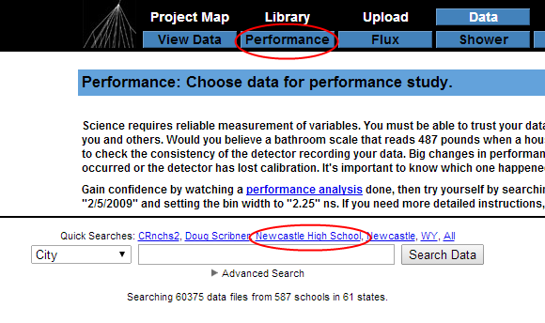
SP:
Part One: Performance Study
Log on to the Quarknet CRMD e-Lab
Click “Data”
Click “Performance”
Select “City” and Type “Newcastle”
Click the drop arrow to the left of Newcastle
Select June 2014
Select Thu 26 Pre
Click the “Run Performance Study” on the right
Under Analysis Control, make sure Channel 1-4 have checks in their boxes
Change Bin Width to 1.25ns
Under Execution Mode, make sure Local is selected
Click Analyze

(Optional) If your data is hard to view, click “change parameters” below the plot (this will bring you back to the “Run Performance Study” page.
Select the drop arrow next to the Plot Control
Change the Xmin, Xmax, Ymin, and Ymax parameters to narrow the field of view of your plots

Save your plots:
SAVE (found below the plots) all figures in the following format
Date_Type of Graph_data set
Ex. June 25_Rates_6446NEWHS26JUN2014STACKED

In a separate window/tab follow Part 1: Performance Study step 1-12
Select Thu 26 Post
Using the same parameters, run a performance study on the second set of data.
Scale your plots as needed and save your second plot.

TC: This is what your student’s Performance Studies should look like.
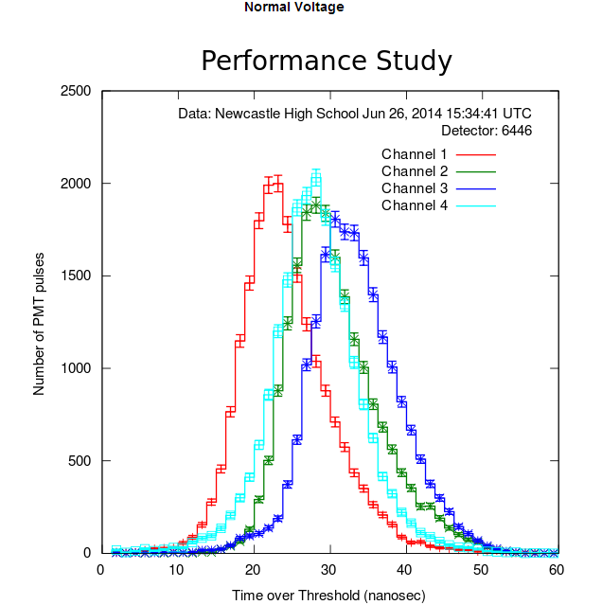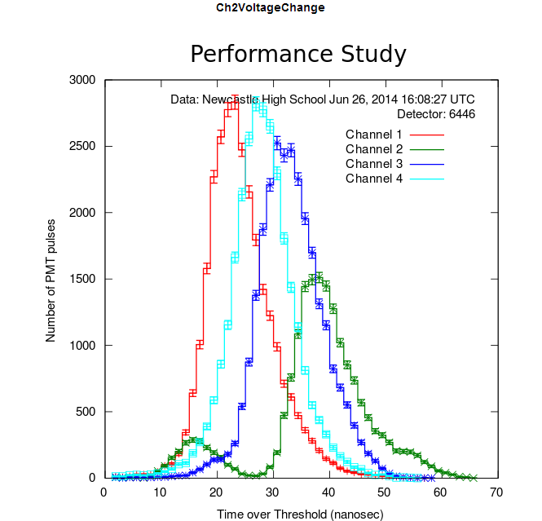

Part Two: Blessing Charts
Click “Data”
Click “View Data”
Select “City” and Type “Newcastle”
Click the drop arrow to the left of Newcastle
Select June 2014
Next to Thu 26 Pre, click the magnifying glass icon
Click “Show Blessing Charts”
Concentrating on Rates and Trigger Rate, rescale the using the Xmin, Xmax, Ymin, and Ymax

Save your charts:
SAVE (found below the plots) all figures in the following format
Date_Type of Graph_data set
Ex. June 25_Rates_6446NEWHS26JUN2014STACKED
In a separate window/tab follow Part Two: Blessing Charts step 1-8
Select Thu 26 Post
Using the same parameters, run a performance study on the second set of data.
Scale your the Rates and Trigger Rate as needed and save your second Blessing Charts.

TC: What has our “adjustment” of the detector caused in reference to the data? Is the data still acceptable? Have students compare their performance studies with those already completed to make sure students conducted the performance study correctly.
Also note that when the voltage on a single counter is changed it will effect the channel rate plot. Scale is extremely important in examination of the data using the Rate plot in eLab.

TC: This is what your student’s Blessing Chart Rates should look like.
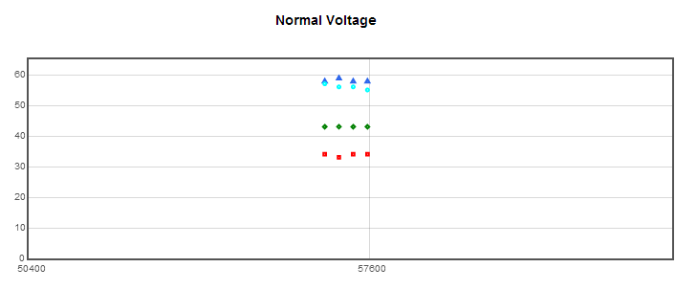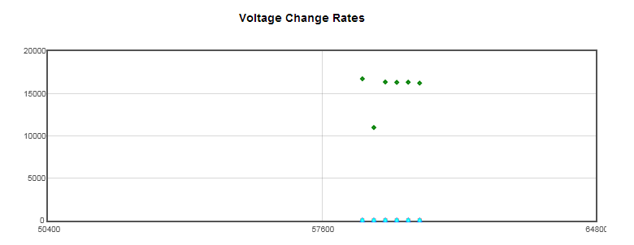
TC: The difference between the plots on the left and right. As you can see the scaling of the right plot does not allow one to see all four channels of data, due to the voltage difference causing channel two to count more hits than the other three channels.

TC: This is what your student’s Trigger Rates should look like. They should not change.
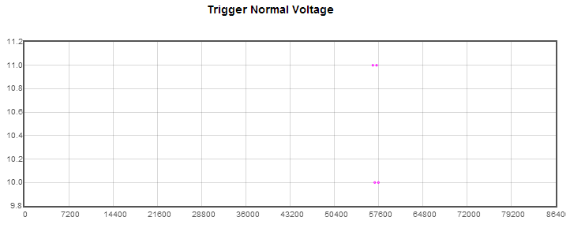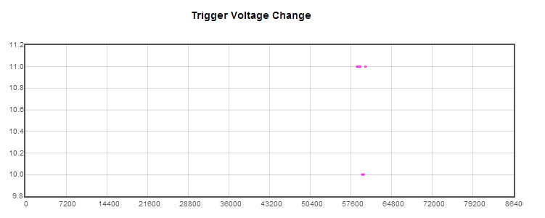
Results/Poster Creation:
SP:
Open up the Cosmic Ray Poster Creator
File name should be Date_Class Period_Initials of all group members separated by dashes
Ex: 6-25-14_3A_JS-ZB-DS
Title: The Effect of…on…
Subtitle: Team Name
Authors: First Name Last Name, …
Date: Today’s Date

Abstract: Shortened version of your work and it should include:
- Objectives of your study
- How did you complete your study. (Abbreviated Procedures)
- What results were obtained
- Significance of the results

Introduction: Background and researchable question
Procedure: How research was performed
Results: Supports claim with data
- Include pictures of your performance studies

Figures and Captions
- All figures you create and compare must be saved with appropriate titles to be inserted into the poster.
- SAVE all figures in the following format
Date_Type of Graph_data set
Ex. June 25_Rates_6446NEWHS26JUN2014STACKED
- Captions must adequately describe the data and make comparisons if necessary.

Assessment

Students will be assessed through the creation and presentation of a group poster. The poster will be created in the eLab and all sections of the template must be completed. Each group will be expected to address the following questions throughout their poster and presentation:

- What does good data look like?
- What is an indication of bad data?
- How can errors be corrected?
- What other investigations could you propose using this CRMD hardware

