Lawrence Berkeley National Laboratory
Annual Report 2016
July 6, 2016

Mentors: Tony Spadafora, Alex Kim, & Alessandra Ciocio
Workshop Coordinator: Laurie Kerrigan
Co- Organizer: Ken Cecire (QuarkNet)

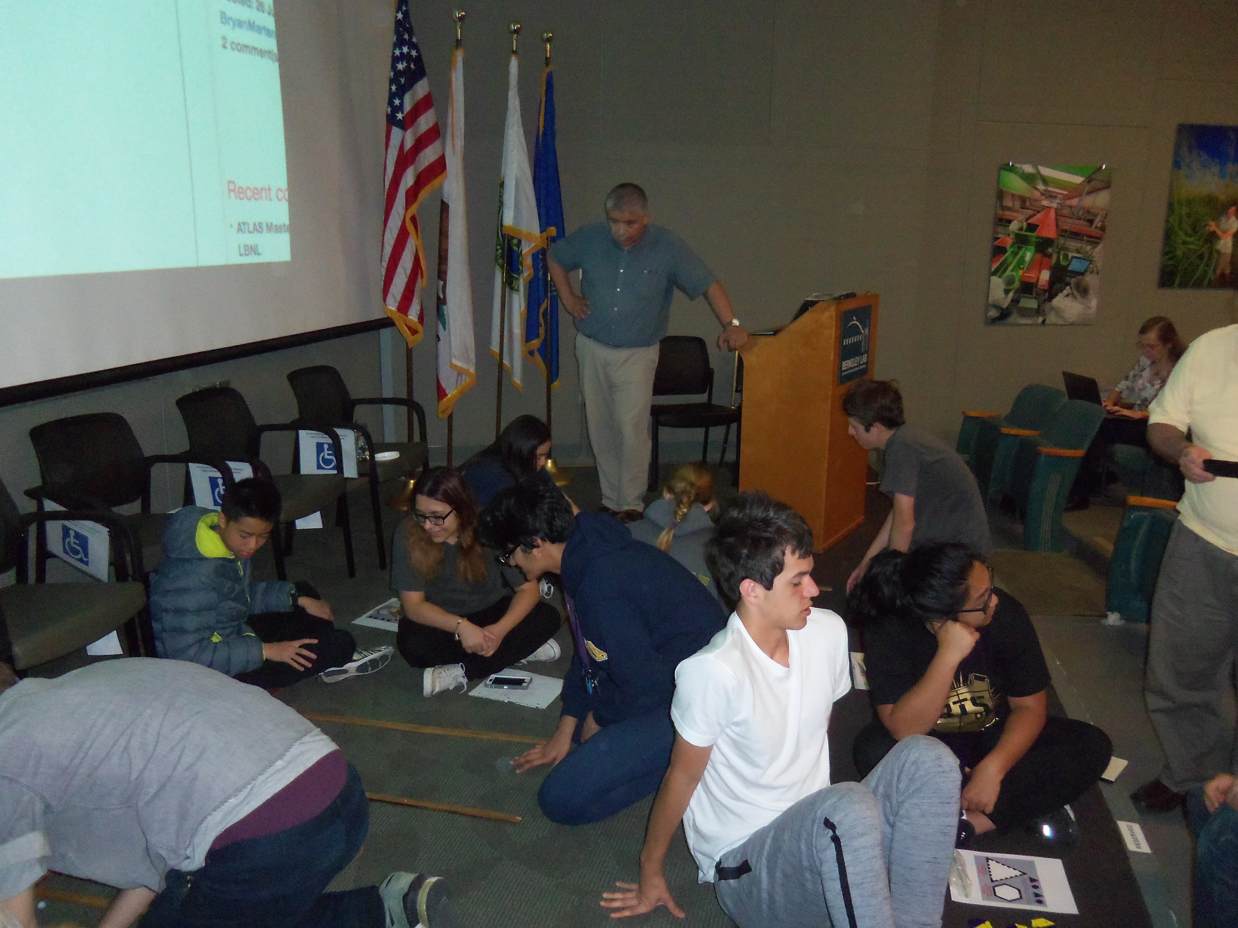
The LBNL Physics Division hosted its tenth “Physics in and Through Cosmology” workshop for QuarkNet Leadership teachers and high school students. The five-day workshop from June 20 to June 24, 2016 was held at the Lawrence Berkeley National Lab. Thirteen science teachers participated. Five of the teachers have been active members of QuarkNet for five or more years. Six new teachers joined the group this year. There were 40 students with approximately equal number of boys and girls. The teachers & students represented public and private high schools in the greater San Francisco Bay Area.

The first day focused on getting all participants familiar with concepts & terms in particle physics & cosmology. This was accomplished through “mini” lectures given by returning QuarkNet teachers & Blake Sherwin, an LBNL researcher. The LBNL 88” cyclotron was also toured.

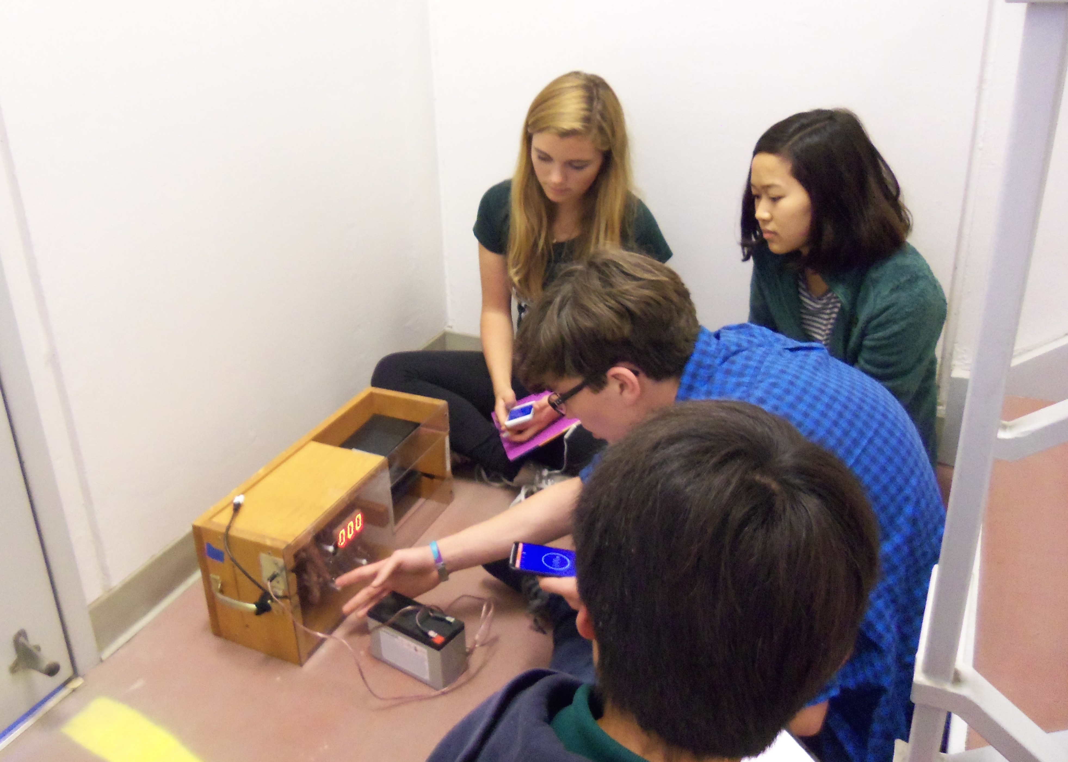
The other days consisted of hands-on warm-up activities, a morning scientist talk and an afternoon talk. Between talks, groups worked on hands-on experiments (e.g. QuarkNet activities lead by Ken Cecire using data from ATLAS). Participants also discussed the lectures. They had a virtual tour of the ATLAS Control Room at the CERN Large Hadron Collider (with more Q&A about Supersymmetry), and viewed Alessandra Ciocio’s ATLAS SCT Cable Installation and Detector Connection video. There were also tours of the ALS (Advanced Light Source) and Molecular Foundry research facilities at LBNL.

Groups designed & carried out experiments with Cosmic Ray Detectors. Each group consisted of four students and one teacher.

Teachers meet with Ken Cecire over lunch on the second day to discuss QuarkNet.

Formal presentations included:
Standard Model and Higgs - Robert Clarke

Beyond the Standard Model, Exotics and Searches - Jennet Dickinson

ATLAS masterclass measurement - Ken Cecire

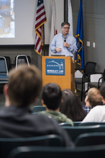
Surprise drop in by Saul Perlmutter

Supernova - Clare Saunders

Dark Matter - Peter Sorensen

CMB - Darcy Barron

LIGO gravitational waves - Brett Noah Shapiro

Rocket Science - George Smoot

Cosmic Rays - Spencer Klein

Panel Discussion - Darcy Barron, Alex Kim, Spencer Klein, Brett Noah Shapiro

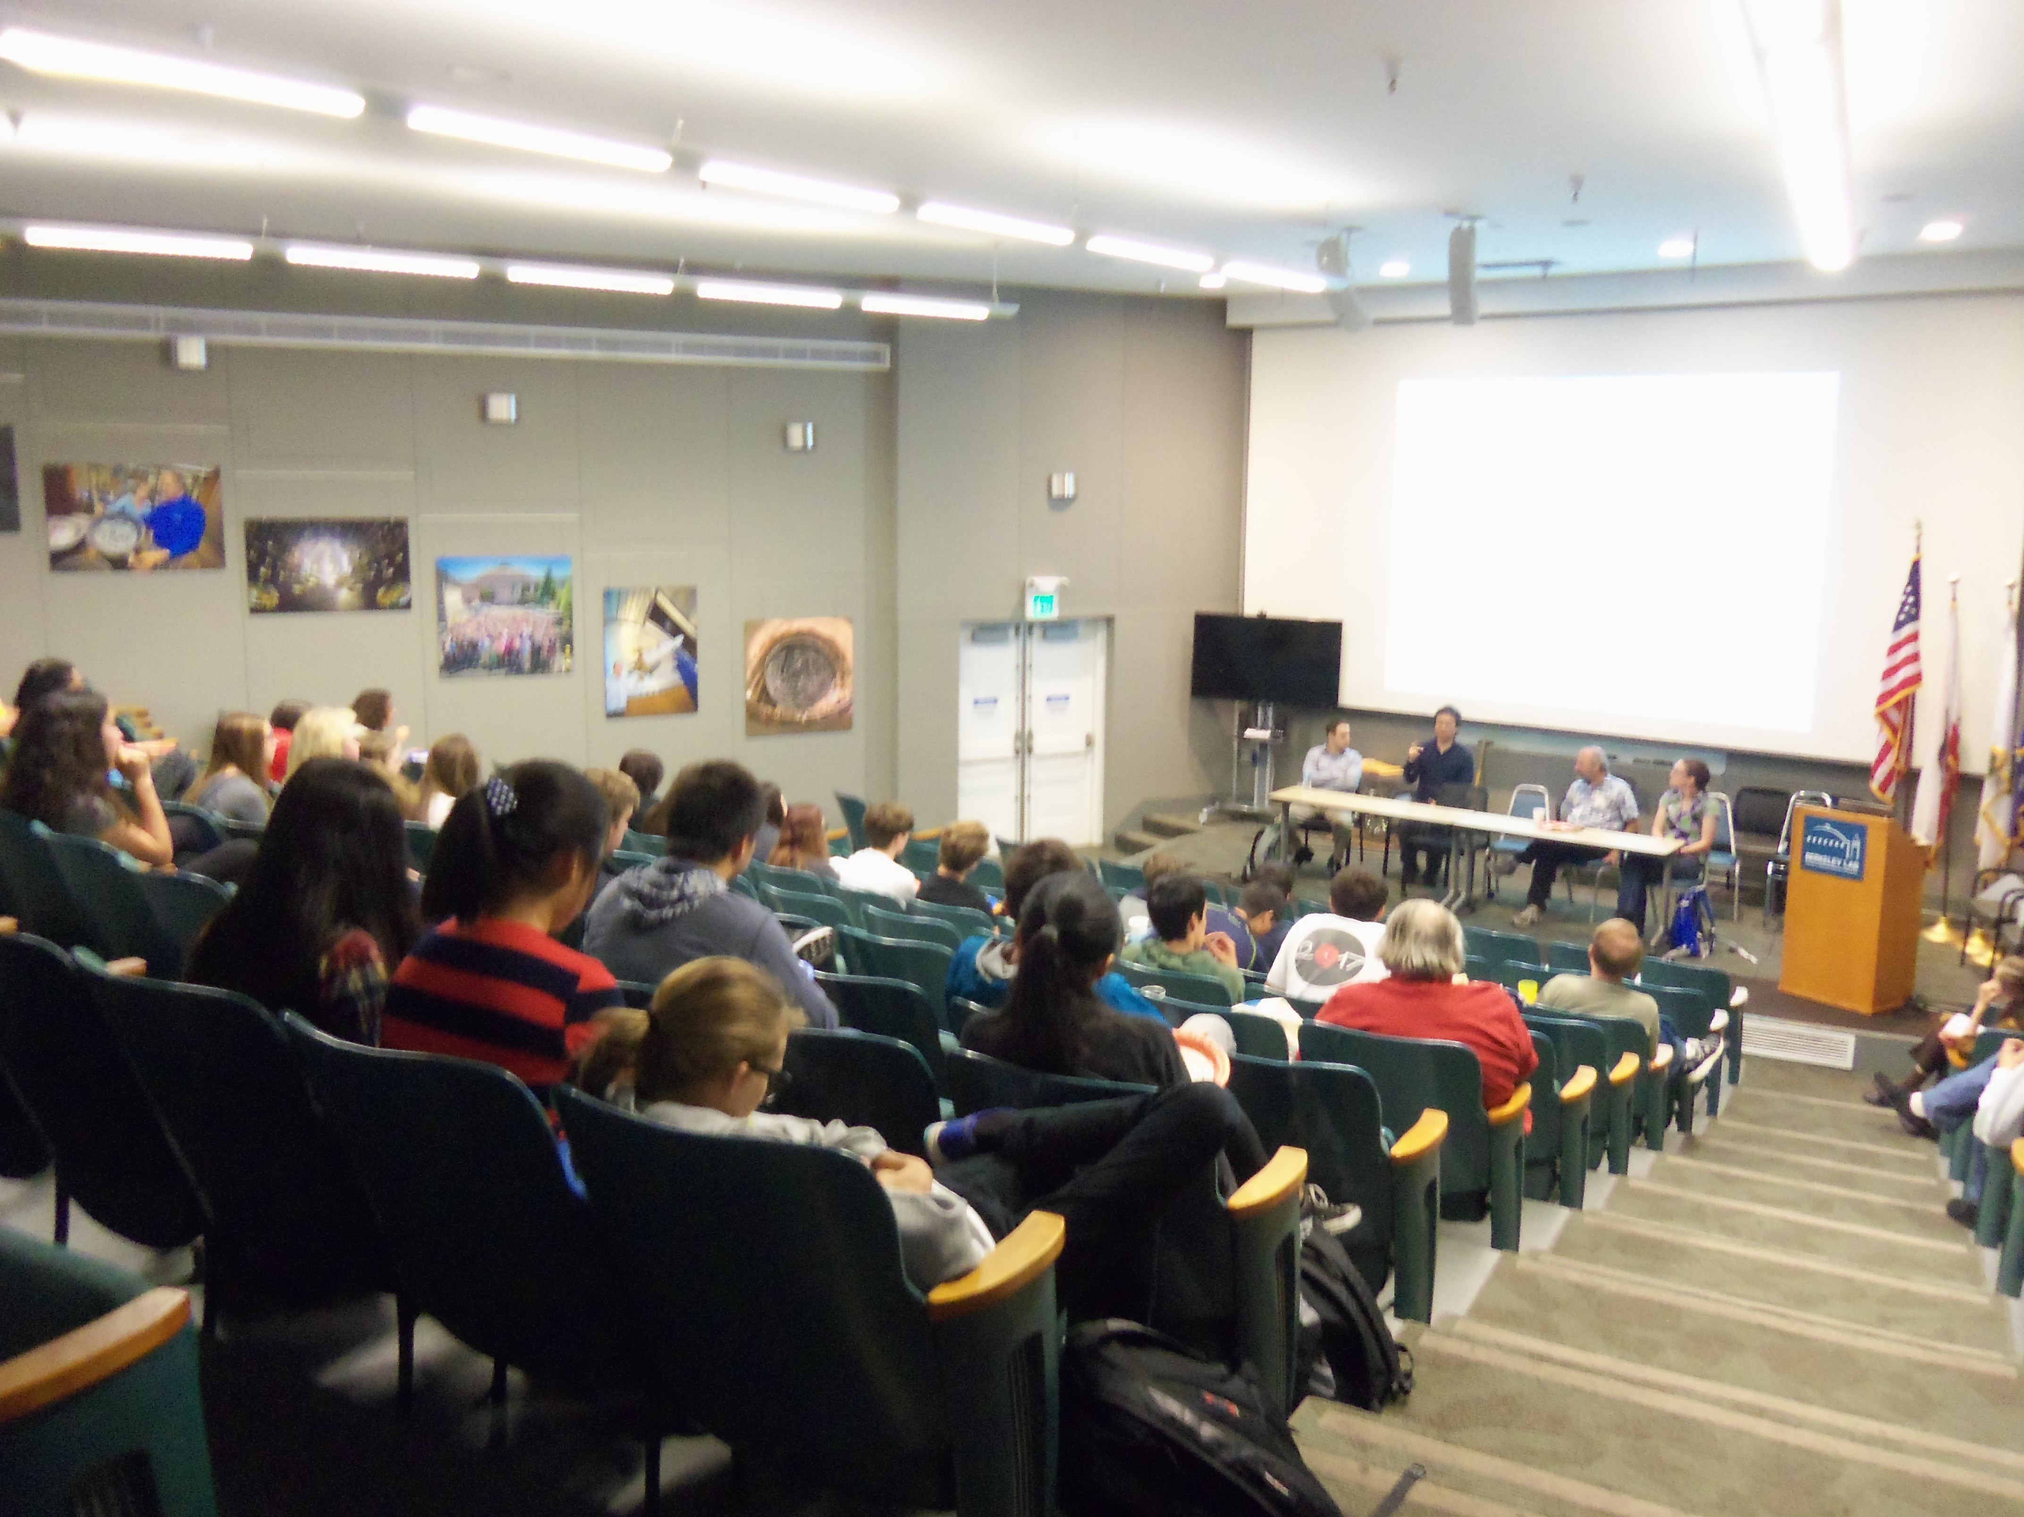

On the last day students completed a self- evaluation of how much they learned about science concepts during the workshop. They used a scale of 1 (nothing) to 5 (a lot).

The overall average for all of the students for all of the concepts was 4.0 with a standard deviation of 0.54

The two concepts with the highest overall evaluation of 4.54 were:
According to the Big Bang Theory the Universe has expanded from initial conditions of
being very small, hot and dense.
The Cosmic Microwave background is the baby picture of the Universe when matter &
energy decoupled

Others that received high marks were:
The Universe is approximately 5% atomic matter, 20% dark matter, and 75% dark energy.
4.49
Cosmic rays interact with material on Earth. 4.49
Space itself is expanding. 4.46
Supernovae are the explosions of dying stars, and certain types can serve as a standard
candle. 4.43
Know that when an observation does not agree with an accepted scientific theory, the
observation is sometimes mistaken or fraudulent (e.g., the Piltdown Man fossil or
unidentified flying objects) and that the theory is sometimes wrong (e.g., the Ptolemaic
model of the movement of the Sun, Moon, and planets). 4.43
Recognize the issues of statistical variability and the need for controlled tests. 4.32
Analyze situations and solve problems that require combining and applying concepts
from more than one area of science. 4.32
Quarks have color & flavor & make up protons & neutrons. 4.24

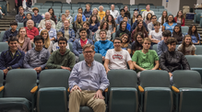
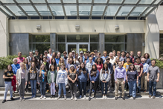
Some comments by the students and teachers include:
Honestly, I learned more in this 1-week period than I did in most full-year science
classes I’ve taken. (student)
I liked seeing all the science labs, and seeing actual scientists doing research. I learned
much about outer space and molecular physics, which I enjoyed because high school
barely covers these topics. (student)
I learned a great deal about current cosmological & particle physics research. (teacher)
It piqued my interest into particle physics. (student)
This definitely opened my mind more about the world around. Before I was taught that
atoms were essentially the smallest unit of matter or whatever and that they couldn’t
be broken down, but, now I know that there’s a whole set of new particles! (student)
I loved learning from experts and being able to ask the difficult questions that my high
school teachers wouldn’t know. (student)
I learned a lot about space from the very large scale universe physics to particle physics,
and the experience was definitely useful in deciding what I would like to study in
college. (student)
I learned more in this one week than I usually learn in a month. (student)

Participating Teachers:

Adams | Ray | retired
Becker | Philip | Las Lomas High
Carlson | Michael | Alameda High
Cooke | Paul | Blue Oak School
Cooper | Susan | Haward
Eldred | Craig | Terra Linda
Garrison | Glenn | Blue Oak School
Guthrie | Laura | Alcalanes
Kerrigan | Laurie | Mercy, S. F.
Marten | Bryan | Lowell
Melnik | Glen | Piedmont
Risk | Valerie | Albany H S
Turney | Kayla | Castro Valley

