DRAFT Cosmic Muon Lifetime
Teacher Notes

Description
There are a number of good activities that connect half-life and lifetime with probability, statistics, and exponential decay. These activities often appear in units about nuclear decay. This activity starts out in a similar fashion but with an emphasis on how muon lifetime is measured in a QuarkNet cosmic ray detector. The lesson then proceeds to the use of plots from the Cosmic Ray e-Lab. The teacher first explains how muon lifetimes are measured in a cosmic ray detector (see Background Material, below).

In the first part of the activity, students initially represent “muons” and their “decay time” is calculated by rolling a die for each. The students and teacher record these decay times and then create a decay histogram as described above. They find half-life and lifetime from the plot. In the second part, students examine actual cosmic ray muon lifetime plots from the Cosmic Ray e-Lab and analyze them much the same way, but this time taking into account that they must define a starting time (t=0 is not necessarily on the plot) and must take an approximately constant noise level above the horizontal axis.

Standards Addressed
Next Generation Science Standards
Science and Engineering Practices
4. Analyzing and interpreting data
5. Using mathematics and computational thinking
Common Core Literacy Standards
Reading
9-12.7 Translate quantitative or technical information . . .
Common Core Mathematics Standards
MP5. Use appropriate tools strategically.
MP6. Attend to precision.
IB Physics Standards
Topic 7.1
Understandings. Half-life.
Application. Investigation of half-life experimentally (or by simulation).
Utilization. Exponential functions.
Topic 7.3
Understandings. Quarks, leptons, and their antiparticles.
Topic 12.2 (AHL)
Understandings. The law of radioactive decay and the decay constant.
Applications and Skills. Solving problems involving the radioactive decay law for
arbitrary time intervals.

Enduring Understandings
- Particle decays are probabilistic for any one particle. The number of particles in a group decreases (in a negative exponential function) from some initial value asymptotically to zero or to a base “noise level”.
- Muon lifetime can be calculated from the time intervals between “double hits” in a cosmic ray counter.

Learning Objectives
Students will know and be able to:
- Precisely record simple observations and plot the results.
- Use an exponential decay curve to find the half-life and lifetime of a particular type of particle.
- Distinguish between half-life and lifetime.
- Account for the possibility of non-muon decays in the data by subtracting out the background.

Prior Knowledge
Students must be able to keep careful records of observations and add integers. Students should be familiar with making and interpreting graphs. An understanding of exponential functions is helpful; lacking this, the activity will help students to understand one type of exponential functions.

Background Material
When elementary particles decay into daughter particles, each particle takes a different amount of time to decay. The process is governed by probability – and different kinds of particles have different probable rates of decay. For example, a π⁺ or π⁻ meson might have a lifetime on the order of tens of nanoseconds while a muon might have a lifetime more in the microsecond range. This means that, for example, in the case of the π⁺ meson, an initial sample N₀ such particles will reduce to N₀/e after one lifetime, N₀/e² after two lifetimes, etc. For any one of these mesons, we cannot predict when it will decay; we can only predict the most likely time it will take to decay.

A detector, especially a QuarkNet cosmic ray muon detector, might capture the particles sequentially and be able to measure the amount of time from initial capture to decay. The initial number of particles N₀ is not affected by whether these particles all start at the same time or are all measured at different times. The decay behavior is not changed.

While particle physicists use particle lifetime, nuclear and atomic physicists as well as other scientists often use half-life, a related term with the same mathematics as above except that it is define as the time (or number of rolls) for N₀ dice to “decay” to N₀/2 dice, etc. Students are more familiar with half-life, though they do not necessarily understand it. They will measure both in this activity.

In a cosmic ray detector, muon lifetimes are measured by the time for muons stopped in the detector to decay:
- A low-energy muon enters a counter, causes an initial scintillation, and stops.
- The time t₁ of resulting signal is recorded.
- After some time, the muon decays into an electron and two neutrinos; there is a second scintillation.
- The time t₂ of resulting signal is recorded.
- The time difference t = t₂ - t₁ is calculated and recorded; this is the amount of time for this particular muon to decay.
- The process is repeated for many more low-energy muon; each has its own value of t.
- A histogram of values of t is made, with time on the horizontal axis and the number of remaining muons not decayed on the vertical axis.
- The half-life of the muon (not generally used by particle physicists but useful to compare with radioactive half-life) is the time for ½ the sample to decay according to N=N₀(2^{-t/t}), where N is the number of muons in the sample, N₀ is the initial number of muons, t is time, and t is the half-life.
- The lifetime of the muon is the time for 1/e of the sample to decay according to N=N₀e^{-t/τ}, where N is the number of muons in the sample, N₀ is the initial number of muons, t is time, and τ is the lifetime.
A fair die has an equal probability of producing any of the available numbers and so can be used to model a single particle. We model this with dice by each of N₀ students having one die and rolling until he or she gets, say, a 6, at which point we say the die has “decayed”. The number of rolls will vary. The lifetime is defined as the time for a sample of N₀ dice to “decay” to N₀/e dice; it takes two lifetimes to decay down to N₀/e² dice, etc.

Implementation
We do not provide a student handout with this activity.

In the first part of the activity, students model the behavior of low-energy muon entering a cosmic ray detector, stopping there, and decaying. The students may line up, each representing a muon. An area of the classroom is designated as “the detector”. One-by-one, the students enter the detector and then a die is rolled until a predetermined number on the die is rolled (e.g. 6) and the student counts how many times he or she had to roll the die to get the desired number. Rolling this number represents a “decay”. The student then leaves the detector and either sits down or rejoins the line to become another muon for greater statistics. For each “muon”, record the number of rolls needed to get to the predetermined number.

With student assistance, make a table and graph space on the board. For zero rolls, put the total number of muons before decay next to 0 rolls in the table. Call out one roll. Count the number of muons that have not yet decayed after that roll and put that number next to 1. Continue until you get to the maximum number of rolls. Then plot the number of remaining dice as a function of the number of rolls. Here is an example of a table and plot from rolling 25 dice:

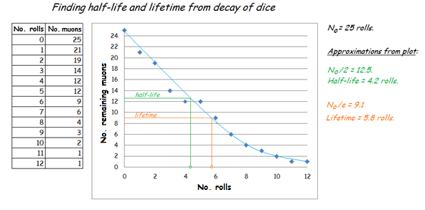

In the second part, students are given actual muon decay plots from the Cosmic Ray e-Lab; it should be stressed to students that these are actual experimental data from muon decays in cosmic ray detectors. The plots for handing out are in a separate document. Students do much the same work in finding half-life and lifetime; however:
- The actual muon lifetime plots do not start with t=0, so students must pick a point on the curve and re-calibrate that to t=0.
- There are background events which look like a muon decay (two distinct scintillations in one counter) but are not real decays: these are accidental combinations of noise in the photomultiplier tubes or single muons. This background is fairly constant.
- As a result, the decay curve follows a function more like N = N_{b} + N₀e^{-t/τ}, with N_{b} as the background level of events and t understood as the time from the initial point chosen on the curve to the point in question.
A sample analysis follows. The e-Lab calculation of muon lifetime is shown; this does not appear in the handout for students.
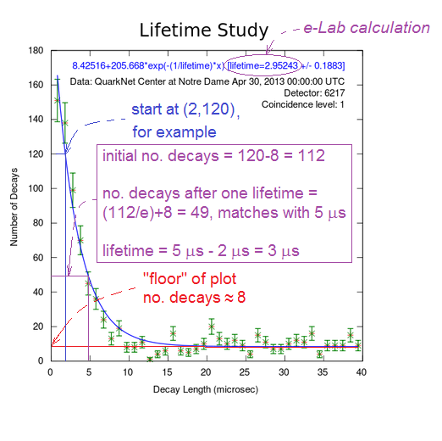
Students should evaluate the plots in small groups. When they finish, a rich discussion of how their results are similar and how they differ – and why – should be pursued in class.

Possible extensions for independent student work, with increasing levels of sophistication:
- If there are multiple classes doing this activity, collect the data from all classes into a table and have students plot it and analyze the data on their own.
- Have students repeat the plot creation and analysis using a spreadsheet and exponential trendline with an equation like N=N₀e^{-kt}. The lifetime should be 1/k and the half-life should be (ln 2)/k. See Background Material above.
- Have students make their own plot from classroom data by hand, make a best fit curve, and then mathematically derive the equation, the lifetime, and the half-life.

Assessment
Have students discuss the plots and analysis in small groups and then report. They should address these questions as well as their own:
- How well does each plot fit using 2 half-lives? With 2 lifetimes? What does this say about the reliability of the plot?
- What would happen if the first experiment were repeated? Would students get the same plot? A different one?
- Why are results from the plots in part two different? How are they similar and why?

Students can also do one of the extensions for evaluation by the teacher.

